ANDROID DOCUMENT

REF

<https://www.figma.com/file/uob9z6FGVkYl8t3gvhl0TL/Car-Park-Booking-App-UI-Kit-(Community)?type=design&node-id=0-1&mode=design&t=XgAhO3edJhNOPKwk-0>

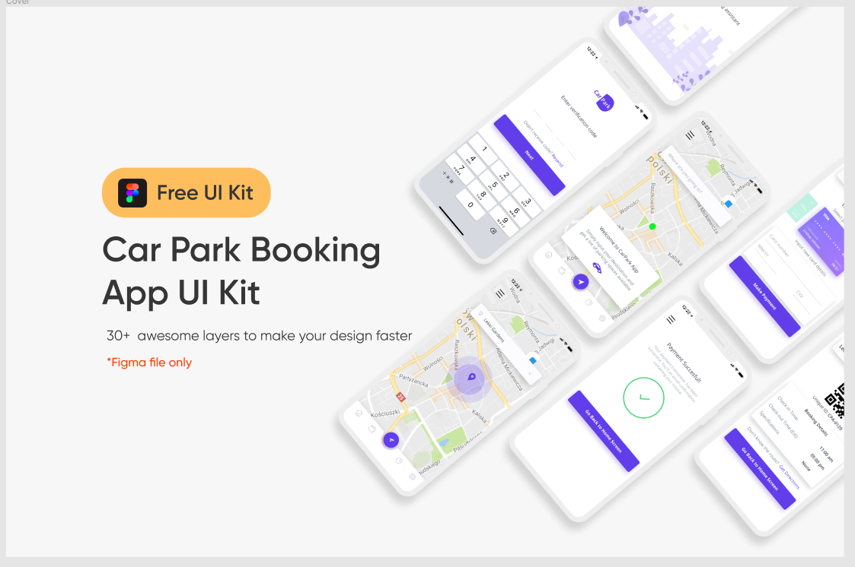

https://www.figma.com/file/NeNbO0DupOtnsqOycgZvjp/Taxi-service-app-(Community)?type=design&node-id=0-1&mode=design&t=h0qnaqB0umx9datI-0

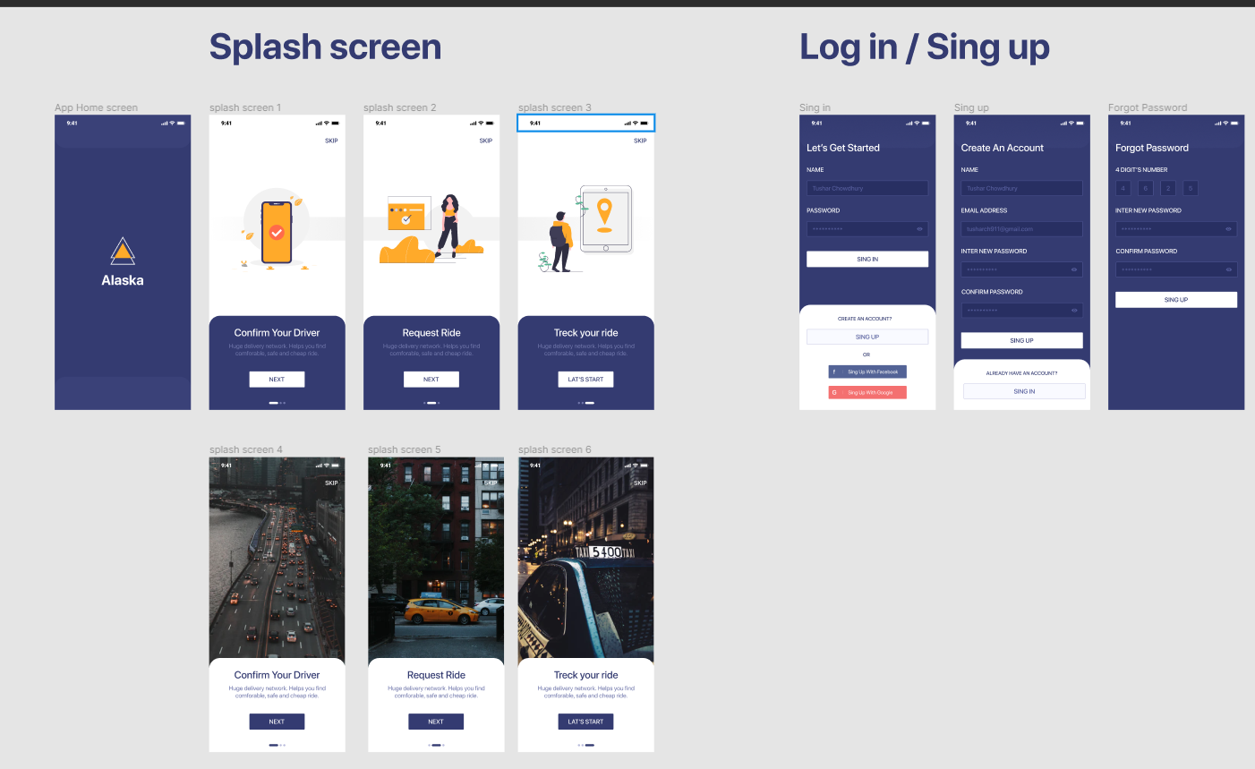

https://www.figma.com/file/VNmC2rPIJpnqujqMTsAGRo/Easy-Ride--Taxi-Booking-App-UI-Kit-%7C-Case-Study-(Community)?type=design&node-id=73-3585&mode=design&t=F0uW97wJDKkexRYt-0

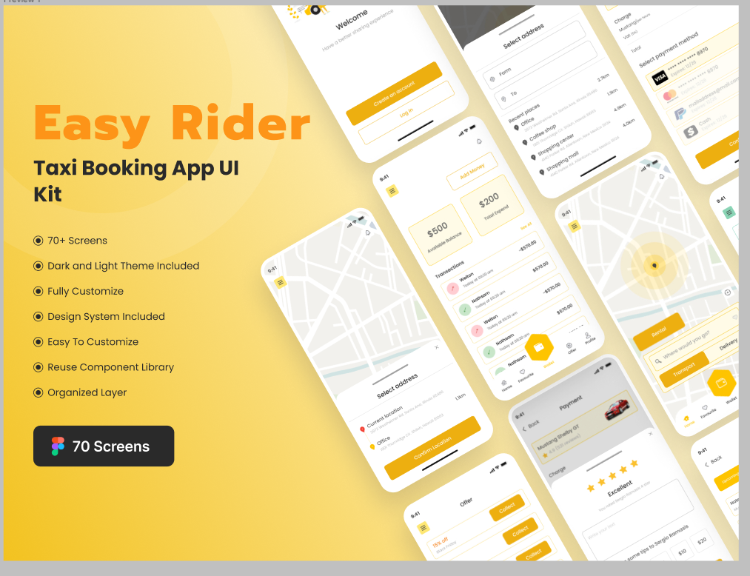

https://www.figma.com/file/Mz7S3Dz7p4VqE1Ojg2wM8w/AI-website-landing-page-(Community)?type=design&node-id=1-2&mode=design&t=mePH04m9r3iDw6qZ-0

